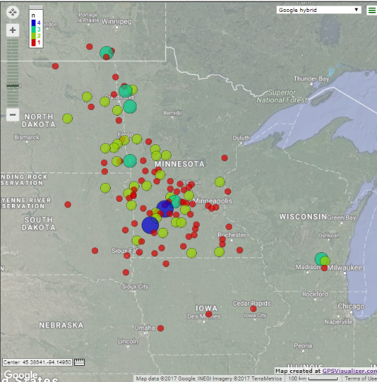
Attendee zip code maps:
- Conference held in St Cloud, MN
- Conference held in Mankato, MN
- Conference held in Fargo, ND

