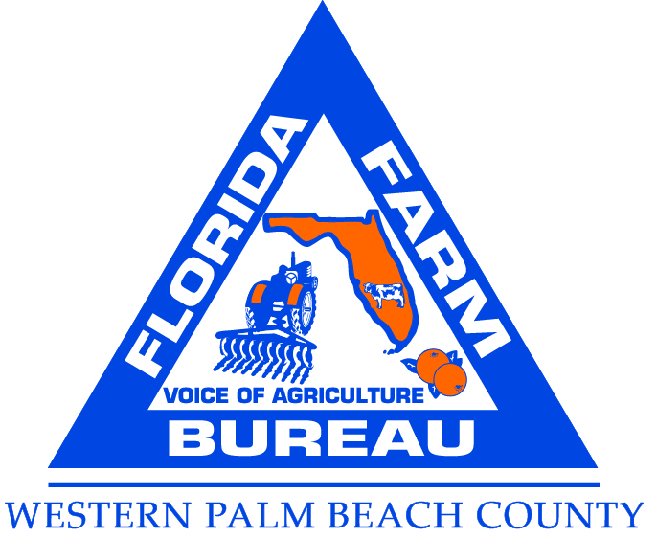 | Western Palm Beach County Farm  3019 State Road 15, Suite 5  Belle Glade, Fl. 33430  Phone 561-996-0343  http://FloridaFarmBureau.org wpbcfarmbureau@gmail.com

January 11, 2022

NACCA Hall of Fame Committee

Re: Eugene McAvoy Nomination Endorsement to NACCA Hall of Fame

Dear Committee Members,

I am writing this letter in support of Gene McAvoy to the NACCA Hall of Fame. I can think of no other more deserving of this great honor. Gene has distinguished himself over the years for his dedication and commitment to Florida Agriculture and Cooperative Extension. He has gone above and beyond in helping to mentor other extension agents for as long as I have known him.

An example of his service, several years ago there was a pepper study being done and the young researcher was experiencing difficulty in getting grower participation. I suggested he contact Gene McAvoy who is highly respected by growers throughout Florida to open a few doors. As a direct result of Gene’s assistance this pepper study was concluded. Also in the early years of 2000, farmers were at risk of losing some important chemicals. A Tallahassee Environmental Engineering Firm, Levine and Fricke was contracted by EPA to do well water testing to determine if there was any contamination. They were not having much success in getting growers around the state to agree to allow them on their lands for this purpose. I was called in by Florida Farm Bureau Federation and Florida Fruit and Vegetable Association to assist a young engineer with this effort. My first call was to my friend Gene McAvoy to help get all the sites needed in SW Florida while I worked on SE Florida. Gene was invaluable in getting the required number of wells matching the specific requirements to allow the study to go forth. It was later concluded there was no contamination of these wells by the chemicals in question. This allowed farmers to use these important tools for a few more years allowing them to find alternatives.

Gene has always answered the call when it came to doing what is right or what is needed with no promise of financial gain for himself. He has served Florida Agriculture selflessly and continuously over the years.

Gene McAvoy is a great communicator; he is prolific in his writings on behalf of agriculture and in the interest of agriculture from research to advocacy. His emails are shared and re-shared throughout the state as a valued source of information. He crosses all the communication styles, he utilizes social media, twitter, Facebook, text messages, blogs and phone calls as well as U.S. Postal Service mail. He prepares presentations for meetings, sends out monthly newsletters regarding IFAS research and helpful information including important issues growers need to be aware of.

Gene has been active with the Hendry Glades County Farm Bureau, Hendry Glades County Cattlemen, Collier County Farm Bureau and Florida Farm Bureau. He has been involved with Florida Ag in The Classroom, Ag Literacy, Farm Tours, local Fairs as well as the Sweet Corn Fiesta. Gene’s contributions extend to no just 4H and FFA but all youth education programs including local Young Farmers and Rancher programs as well as Florida Farm Bureau State Young Farmer and Rancher programs. He participates in Congressional tours helping to educate our leaders of the importance of agriculture and research and development. He is called upon by the media as an expert on Agriculture and Research. He has testified in Trade hearings, Congressional hearings etc. as well as Florida Ag Committee hearings on Agriculture issues.

Gene works with growers throughout South Florida regarding science and technology
To help them be more productive and profitable. He is an outstanding spokesperson for agriculture and UF IFAS Extension. He does tours of agriculture for various chamber of commerce’s each year as well as for 4H and other not for profits. There is no one more helpful or knowledgeable or as well known as Gene McAvoy “Mr. Agriculture”. Gene has done much to change the perception of agriculture in our region and state of Florida.

Gene has been known to travel from one end of the state to another to meet with a farmer having a problem. Gene never turns off his phone, he has never had an 8 to 5 job. I do not know of any farmer that does not know or heard of Gene McAvoy. He has had a tremendous impact on Florida Agriculture while elevating the image of the University of Florida and Extension Agents.

Gene does not limit his involvement to Agriculture, he is actively involved in his community serving for many years the Disaster Management Team. During natural disasters such as hurricanes he is working to protect, safeguard and providing vital support and service to those impacted helping to save lives and property. After the storms and or disasters Gene is out assessing damages, lending support helping to rebuild lives. He provides valuable information to government agencies needing economic information for crops lost and damages to agricultural properties in SW Florida. He has been known to be the first on the scene assessing damage. He has sacrificed his own comfort for others.

Gene McAvoy is an outstanding spokesperson for Agriculture and advocate for UF IFAS Extension. He is unafraid to stand up and speak out on unfair trade practices and policy.

I have such a high regard for this gentleman and his accomplishments. One of his achievements is the South Florida Vegetable Pest and Disease Hotline. A biweekly newsletter produced by Gene providing growers with updated info on pests and disease affecting vegetables in South Florida but not limited to South Florida. This newsletter has proven a successful communication tool for the vegetable industry and currently reaches over 1500 individuals and businesses covers all of South Florida vegetable production areas. It is copied and distributed throughout the state.

The need for this hotline became apparent at a meeting in SW Florida Vegetable Advisory Committee in October of 1998 where growers and others indicated a need for information on the incidence and occurrence of pests and diseases affecting vegetables. The concept was quite simple; pests and disease are a constant dynamic threat to vegetable producers and timely relevant information is required by growers to aid management effort. This news letter is now in its 22 year of publication and is recognized as the premier vegetable pest and disease newsletter in Florida and has achieved national recognition being noted in EPA web-based listing of US IPM Newsletters.

I could go on and on regarding how impactful Gene McAvoy has been since arriving in Florida. My personal observation is Mr. McAvoy sees a need and strives to meet that need, over and over again.

It has been a great privilege and honor to know and occasionally collaborate with Gene McAvoy. I strongly and enthusiastically endorse Mr. Gene McAvoy for the NACAA Hall of Fame.

Respectfully,
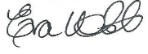

Eva Webb
Director
Western Palm Beach County Farm Bureau
(Retired Florida Farm Bureau Federation, Field Representative District 8)

