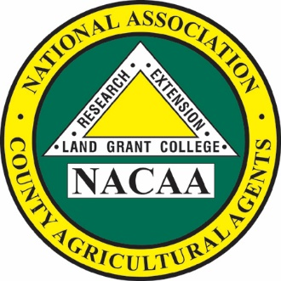

Bill Burdine

*President*

107th Annual Meeting

July 17-22, 2022

West Palm Beach, FL

*NACAA is an Equal Opportunity*

*Professional Association*

**National Association of County Agricultural Agents**

NACAA Headquarters

6584 W. Duroc Road

Maroa, IL 61756

Phone: 217-794-3700 Fax: 217-794-5901

Email: nacaaemail@aol.com

www.nacaa.com

President’s Address

Bill Burdine

P.O. Box 2297  
Tupelo, MS 38803

Phone: 662.841.9000 Cell: 662.321.5356

Email: bill.burdine@msstate.edu